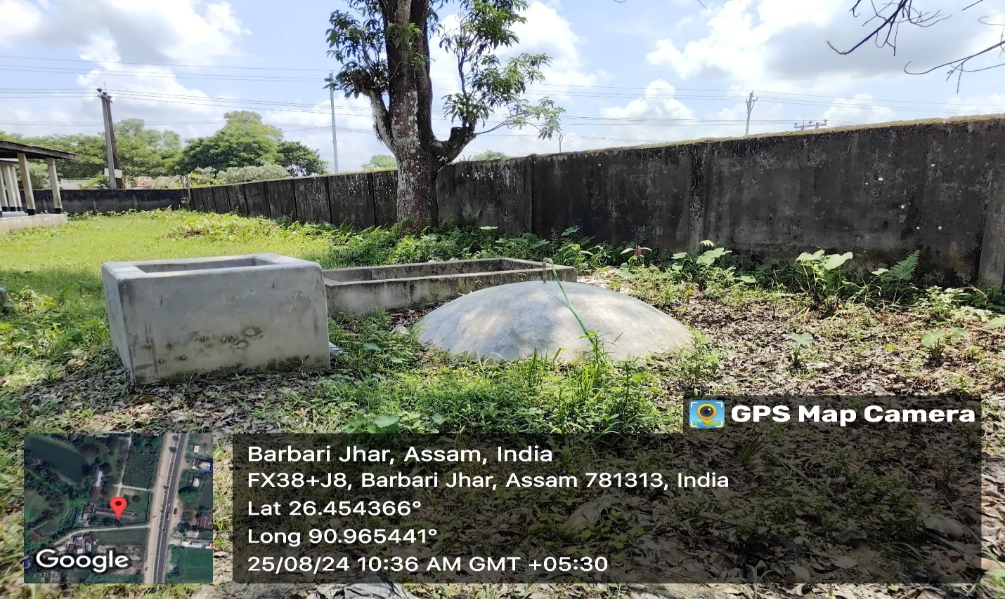
Biogas Plant set up in Men’s Hostel, B.H. College
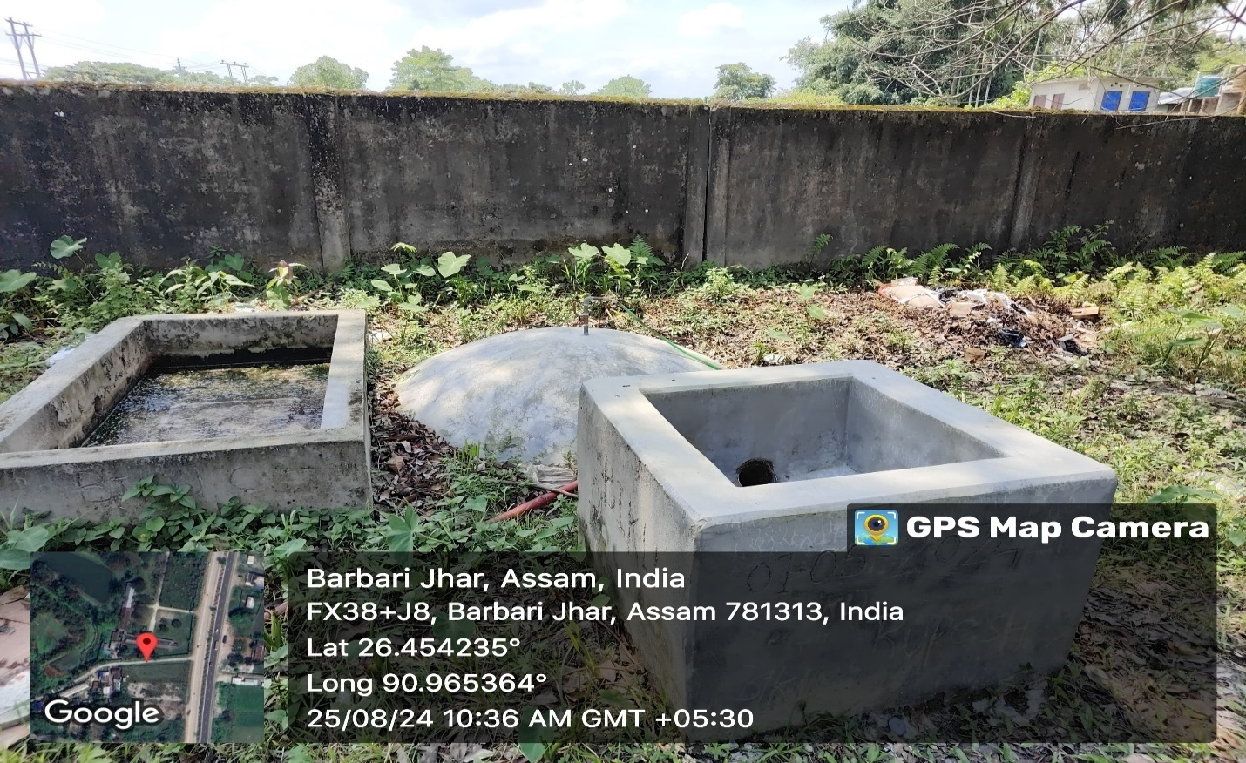
Biogas Plant set up in Women’s Hostel, B.H. College, Howly

